Naztech.com.au — Daily Tasks
Prepared for developer handoff. Source: Naztech.com.au-Keyword-URL-Meta.xlsx, sheet 'Meta Data' only. Live site checked 9 Jul 2026.

1. Rename existing pages + add 301 redirects
These two pages already exist on the live site. The Meta Data sheet explicitly notes their current URL — rename them and 301 redirect the old URL to the new one. Do not create new pages for these; update the existing ones in place.
- Change URL from https://naztech.com.au/pakenham/ to https://naztech.com.au/mobile-auto-electrician-pakenham/ and add a 301 redirect from https://naztech.com.au/pakenham/ to https://naztech.com.au/mobile-auto-electrician-pakenham/
- Change URL from https://naztech.com.au/cars/ to https://naztech.com.au/car-aircon-regas/ and add a 301 redirect from https://naztech.com.au/cars/ to https://naztech.com.au/car-aircon-regas/
Note: this page (Pakenham) is also the structural TEMPLATE for the entire mobile-auto-electrician suburb silo — see Section 2 and the annotated screenshot in Section 6.

2. Create new location pages (using Pakenham as the template)
Using https://naztech.com.au/pakenham/ (soon to be /mobile-auto-electrician-pakenham/) as a template, create these new pages and add content in them. Keep the same layout/section structure: H1 'Mobile Auto Electrician in [Suburb]', a 'Services in [Suburb]:' service-tile grid, and a 'Why Choose NAZTECH in [Suburb]?' USP block. Swap the suburb name throughout and localise the intro paragraph per suburb.

2a. Mobile Auto Electrician — suburb pages (13 new)
Pakenham is excluded here — it already exists and is handled by the rename in Section 1.
- https://naztech.com.au/mobile-auto-electrician-dandenong/
- https://naztech.com.au/mobile-auto-electrician-narre-warren/
- https://naztech.com.au/mobile-auto-electrician-berwick/
- https://naztech.com.au/mobile-auto-electrician-officer/
- https://naztech.com.au/mobile-auto-electrician-clyde/
- https://naztech.com.au/mobile-auto-electrician-cranbourne/
- https://naztech.com.au/mobile-auto-electrician-frankston/
- https://naztech.com.au/mobile-auto-electrician-mornington/
- https://naztech.com.au/mobile-auto-electrician-lilydale/
- https://naztech.com.au/mobile-auto-electrician-warragul/
- https://naztech.com.au/mobile-auto-electrician-traralgon/
- https://naztech.com.au/mobile-auto-electrician-leongatha/
- https://naztech.com.au/mobile-auto-electrician-wonthaggi/

2b. Car Aircon Regas — suburb pages (14 new)
No page in this silo exists yet — not even for Pakenham. Build the FIRST page in this list as the new template (following the same structure as the Pakenham auto-electrician page, but with air conditioning/regas service content), then replicate it across the remaining 13 suburbs.
- https://naztech.com.au/car-aircon-regas-dandenong/
- https://naztech.com.au/car-aircon-regas-narre-warren/
- https://naztech.com.au/car-aircon-regas-berwick/
- https://naztech.com.au/car-aircon-regas-officer/
- https://naztech.com.au/car-aircon-regas-pakenham/
- https://naztech.com.au/car-aircon-regas-clyde/
- https://naztech.com.au/car-aircon-regas-cranbourne/
- https://naztech.com.au/car-aircon-regas-frankston/
- https://naztech.com.au/car-aircon-regas-mornington/
- https://naztech.com.au/car-aircon-regas-lilydale/
- https://naztech.com.au/car-aircon-regas-warragul/
- https://naztech.com.au/car-aircon-regas-traralgon/
- https://naztech.com.au/car-aircon-regas-leongatha/
- https://naztech.com.au/car-aircon-regas-wonthaggi/

2c. Car Battery Replacement — suburb pages (14 new)
Same as above — no page in this silo exists yet. Build the first suburb page as the new template (battery replacement service content, same structural layout), then replicate across the remaining 13 suburbs.
- https://naztech.com.au/car-battery-replacement-dandenong/
- https://naztech.com.au/car-battery-replacement-narre-warren/
- https://naztech.com.au/car-battery-replacement-berwick/
- https://naztech.com.au/car-battery-replacement-officer/
- https://naztech.com.au/car-battery-replacement-pakenham/
- https://naztech.com.au/car-battery-replacement-clyde/
- https://naztech.com.au/car-battery-replacement-cranbourne/
- https://naztech.com.au/car-battery-replacement-frankston/
- https://naztech.com.au/car-battery-replacement-mornington/
- https://naztech.com.au/car-battery-replacement-lilydale/
- https://naztech.com.au/car-battery-replacement-warragul/
- https://naztech.com.au/car-battery-replacement-traralgon/
- https://naztech.com.au/car-battery-replacement-leongatha/
- https://naztech.com.au/car-battery-replacement-wonthaggi/

3. Create new general (root) service pages
These are broader, non-suburb-specific pages — one per service silo. They should be more comprehensive than the suburb pages (equipment lists, FAQ, reviews), similar in depth to the existing /auto-electrical-services/ and /mobile-air-conditioning-repairs-servicing/ pages. Note: those two existing pages are NOT being redirected or renamed — they stay live as-is. Use them only as a structural/content-depth reference, not as a redirect source.
- https://naztech.com.au/car-aircon-regas/ — target keyword: "car aircon regas south east melbourne & gippsland". New page (marked new in the Meta Data sheet). Note the /cars/ → /car-aircon-regas/ rename in Section 1 covers the URL move; this page needs full new content built to this richer template depth.
- https://naztech.com.au/car-battery-replacement/ — target keyword: "car battery replacement south east melbourne & gippsland". Brand new page and URL — no prior page exists for this service at all.
⚠️ Needs confirmation before dev starts: https://naztech.com.au/mobile-auto-electrician/ — target keyword: "mobile auto electrician south east melbourne & gippsland". This URL currently returns 404 (does not exist), but it is NOT marked yellow/new in the Meta Data sheet, and there is no "Current URL" redirect note pointing to it either (unlike the other two rows above it). The existing /auto-electrical-services/ page is a very close content match for this exact target keyword. Please confirm with the client/analyst whether this should be (a) a new page built from scratch, or (b) a rename+redirect of /auto-electrical-services/ — the Meta Data sheet is inconsistent on this one specific row.

4. Update content on existing pages (no URL change)
Make a backup of the contents of the following pages, then update the content in place once new copy is ready. These pages already exist at the correct target URL — no rename or redirect needed.
- https://naztech.com.au/ (Homepage) — target keyword: "mobile auto electrical & air conditioning south east melbourne & gippsland". Current H1 ("Mobile Auto Electrical & Air Conditioning for Heavy Equipment, Fleet & Plant") targets equipment type, not the geographic modifier — H1 and hero copy need to be realigned to the target keyword. See annotated screenshot in Section 6.
- https://naztech.com.au/air-conditioning/ — target keyword: "car air con service and repair south east melbourne & gippsland". Existing page, currently thin (~500 words) relative to the site's richer service pages — needs expanded content to match keyword intent.
- https://naztech.com.au/about/ — not an SEO keyword target. Per the Meta Data sheet: needs E-E-A-T content additions — something about the team, mention achievements, and check the client's onboarding form data for any useful details (certifications, experience, notable jobs) that can be added to this page.

5. Rebuild /areas-we-serve/ as the suburb hub page
This page already exists but is marked as a new build in the Meta Data sheet — treat it as a substantial rebuild, not a small edit. Target keywords: "mobile auto electrician near me", "car aircon regas near me", "car battery replacement near me".
- This page should become the internal-linking hub for all 41 new suburb pages created in Section 2 (42 once Pakenham's mobile-auto-electrician page is included) — grouped into three lists by service silo (Mobile Auto Electrician / Car Aircon Regas / Car Battery Replacement), each suburb linking to its matching page.
- This is the natural page to target the three "near me" keyword variants, since it's the only page covering all three services across the full suburb list in one place.

6. Homepage — annotated changes
Update https://naztech.com.au/ as per this screenshot:
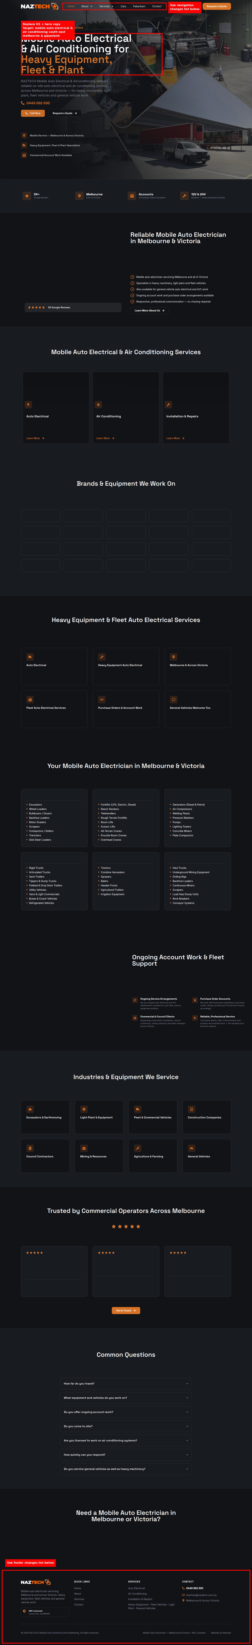

7. Suburb page template — annotated reference
https://naztech.com.au/pakenham/ (soon to be /mobile-auto-electrician-pakenham/) shown below as the structural template for all new suburb pages in Section 2:
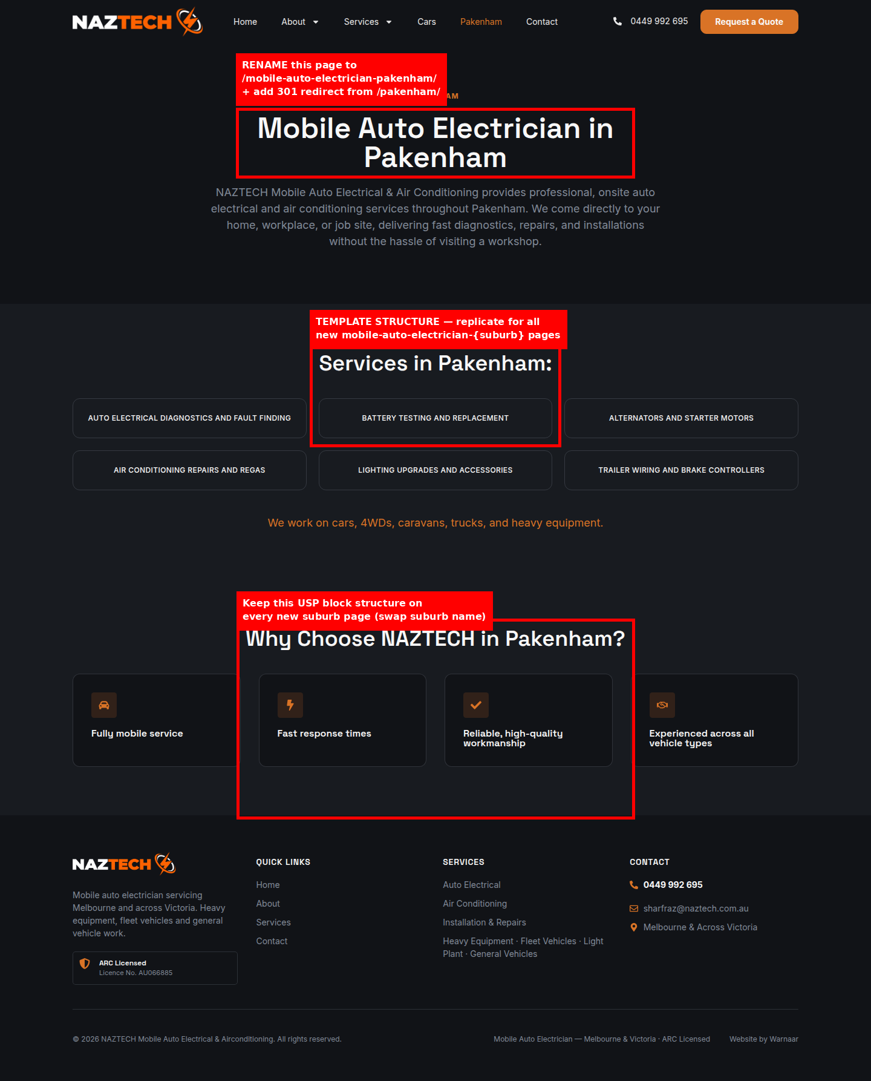

8. Main navigation changes
Current top-level nav: Home / About (▾ Gallery) / Services (▾ Areas we serve) / Cars / Pakenham / Contact
- Remove the standalone "Cars" nav item (page is being renamed — see Section 1).
- Remove the standalone "Pakenham" nav item (page is being renamed — see Section 1); Pakenham remains reachable via the suburb hub at /areas-we-serve/ and via the Mobile Auto Electrician dropdown below.
- Under "Services", add three new dropdown items linking to the new general pages: "Mobile Auto Electrician" → /mobile-auto-electrician/, "Car Aircon Regas" → /car-aircon-regas/, "Car Battery Replacement" → /car-battery-replacement/.
- Keep "Areas we serve" under Services as-is — it will link out to all suburb pages once rebuilt (Section 5).

9. Footer changes
Current footer "Services" column links to: Services, and a standalone "Air Conditioning" link. Update as follows:
- Replace the single "Air Conditioning" footer link with three links: "Mobile Auto Electrician" → /mobile-auto-electrician/, "Car Aircon Regas" → /car-aircon-regas/, "Car Battery Replacement" → /car-battery-replacement/.
- Remove any footer reference to /cars/ or /pakenham/ if present, since both are being renamed (Section 1).

10. Open items — confirm before/during dev
- mobile-auto-electrician/ redirect ambiguity — see red flag in Section 3.
- Suburb count check: this Meta Data sheet lists 14 suburbs per silo (Dandenong, Narre Warren, Berwick, Officer, Pakenham, Clyde, Cranbourne, Frankston, Mornington, Lilydale, Warragul, Traralgon, Leongatha, Wonthaggi). The earlier finalised keyword research (client memory, KWR Phase 0) listed 15 suburbs including Mooroolbark, and used "Clyde North" rather than "Clyde". Since the instruction is to work strictly from the Meta Data sheet, this daily task follows the sheet's 14-suburb / "Clyde" version — flagging the discrepancy in case Mooroolbark was intentionally dropped or needs to be added back.
- Titles, meta descriptions, H1s, H2s, H3s and interlinking words are blank for every row in the Meta Data sheet — this daily task covers URL structure, redirects, templates, nav and footer only. Actual page copy is a separate, upcoming content deliverable.

